FLOW STRESS PREDICTION:
ALUMATECH PLATE STRETCHING
INTRODUCTION
- Stretch Forces: AlumaTech used basic historical averages to predict the flow stress/force needed to stretch new aluminum plates.
- Consequences: This risks equipment damage, if forces are higher than expected.
- Opportunity: AlumaTech has 10+ years (500k+ records) of historical data from plate stretching. This data was leveraged to build a prediction model, allowing engineers to evaluate new plate designs upfront.
- Goal: Develop an accurate model covering all key alloys and plate sizes to forecast the flow stress of the plate which can translate to the required pull force.

DATA & PREPARATION
- Data Source: 2013–2023 stretcher operation logs (post-cleaning ~486,000 stretches). Each record includes: Alloy, Thickness, Width, Length, Stretch % target, and resulting Flow Stress (psi).
- Initial Cleaning: Removed duplicate entries, obvious errors (e.g. zero dimensions), and implausible outliers (flow stress > 60 ksi).
- Focused Dataset: Filtered down to 18 core alloy types (removed minor alloys with insufficient data). Final dataset covers the alloys and gauge ranges of interest, with consistent, high-quality records for modeling.
- Result: A structured dataset ready for analysis, with known inputs (plate specs) and outputs (flow stress) for each stretch.

EXPLORATORY ANALYSIS
- Bimodal Stress Distribution: The historical data showed two clusters of flow stress: roughly 15–20 ksi vs. 35–45 ksi. This corresponds to different alloys – softer alloys consistently stretch at lower stress, high-strength alloys at much higher stress.
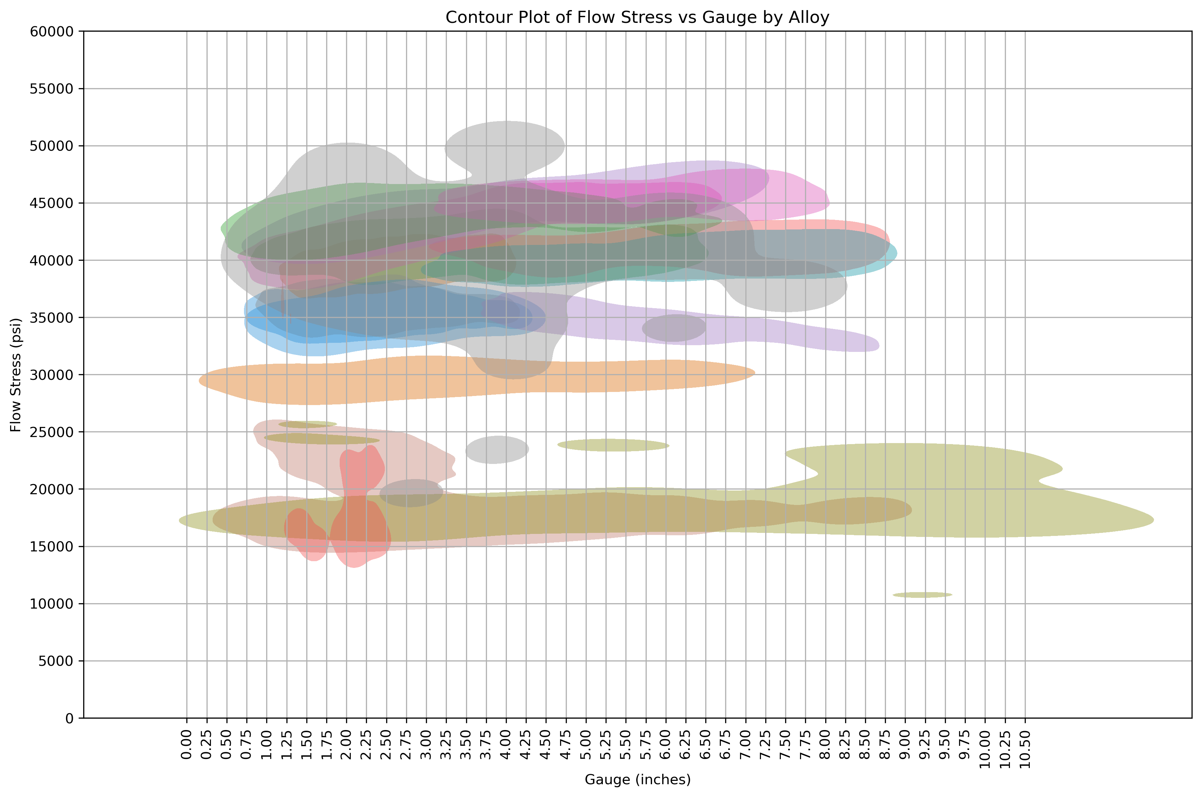
- Alloy is the Key Factor: Each alloy exhibits a characteristic flow stress range. Example: A high-strength alloy’s median flow stress ~40 ksi, whereas a more ductile alloy’s median is ~15 ksi. Alloy type alone explains the largest variation in required force.
- Thickness Effect: Plate thickness (gauge) has the next highest influence: thicker plates generally have higher stress to achieve 2% stretch.
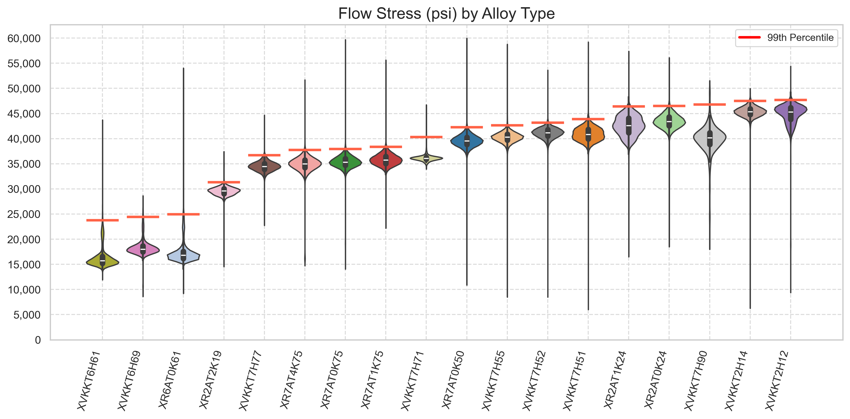
- Implication: The data confirms our model should heavily weight alloy and include thickness. Other factors (width, length, stretch % target) showed smaller correlations with flow stress, but are still known inputs and were used in the models.

MODEL DEVELOPMENT APPROACH
- Modeling Strategy: A combination of models were pursued to predict flow stress from known inputs:
  - Linear Regression: Baseline multi-linear model (one-hot encodings for alloy) to see how well a simple linear combination fits the data.
  - Ensemble Trees (Random Forest): To capture any non-linear interactions between features (e.g. alloy-specific thickness effects). Tuned via cross-validation for ~150 trees, depth ~30.
  - Quantile Regression (LightGBM): A specialized model to predict the 99th percentile of flow stress (worst-case). This provides a safety margin estimate – ensuring we rarely under-predict required force.
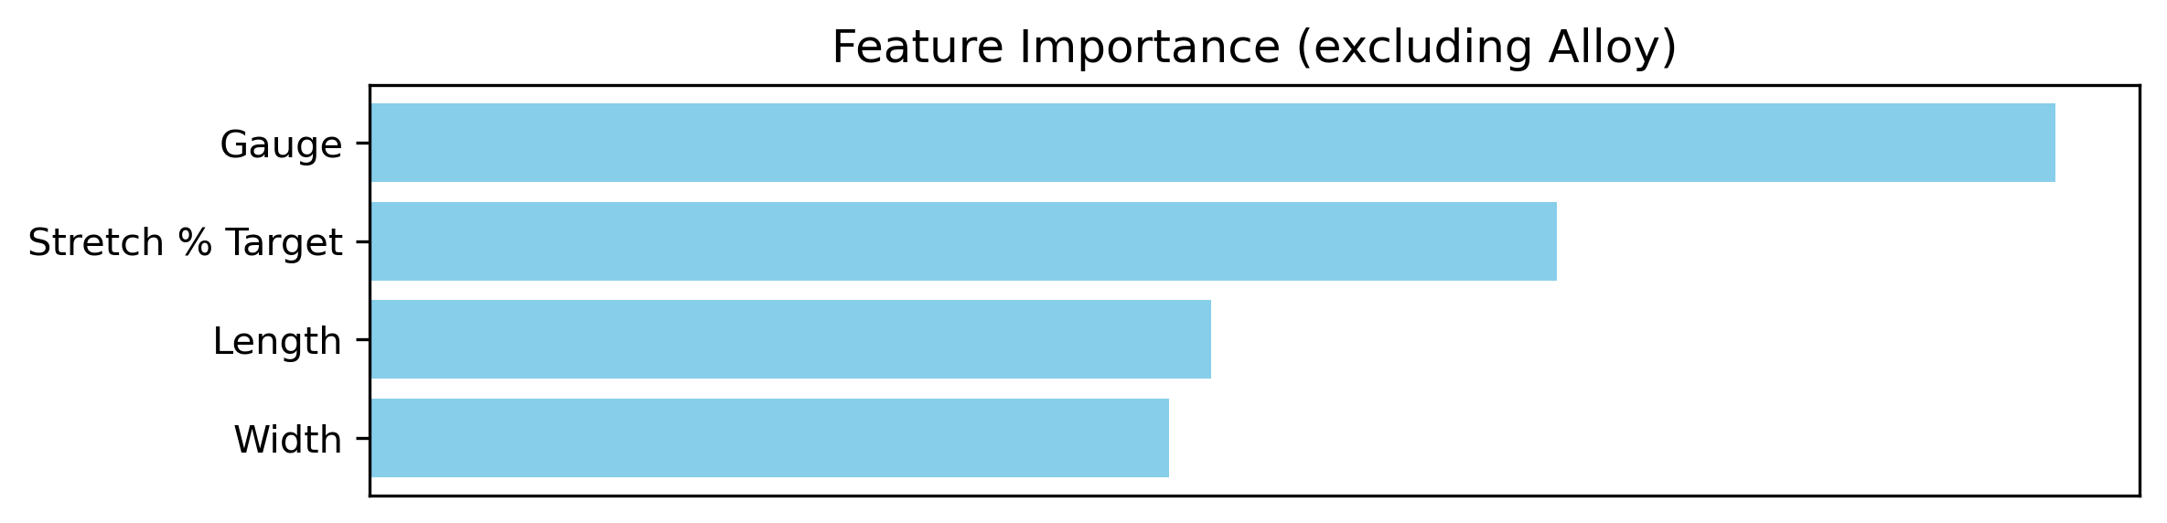
- Features Used: Alloy (categorical – 18 levels), Thickness, Width, Length, and Stretch % (numeric). Alloys were one-hot encoded and numeric features standardized.

- Training: Used an 80% training split (stratified by alloy) and 20% test split for evaluation. Employed 5-fold cross-validation on training data for hyperparameter tuning (especially for Random Forest and LightGBM models).
- Regularization: Ridge/Lasso regularization on the linear model offered no improvement (the linear fit was already robust). This indicated minimal overfitting given our large sample size.

MODEL PERFORMANCE – EXPECTED OUTCOME
- Random Forest (Mean Prediction): This model achieved R² ≈ 97.7% on test data – meaning it explains ~98% of the variance in flow stress. The RMSE ~1.39 ksi and MAE ~0.90 ksi indicate very high accuracy (only ~3% error on a ~30 ksi scale).
- Linear vs. RF: The linear regression already did well (R² 97.6%), confirming largely linear relationships. The Random Forest reduced error slightly (capturing small non-linear nuances, e.g. alloy-specific trends).
- Feature Importance: The model indeed relies mostly on Alloy and Thickness. In the random forest, >95% of decision splits involved alloy or gauge. Stretch target mattered only when it strayed from 2%.
- Verification Plot (Test Set): Predicted vs. Actual Flow Stress – points lie tightly along the 45° line, showing predictions align with actual values across the range.

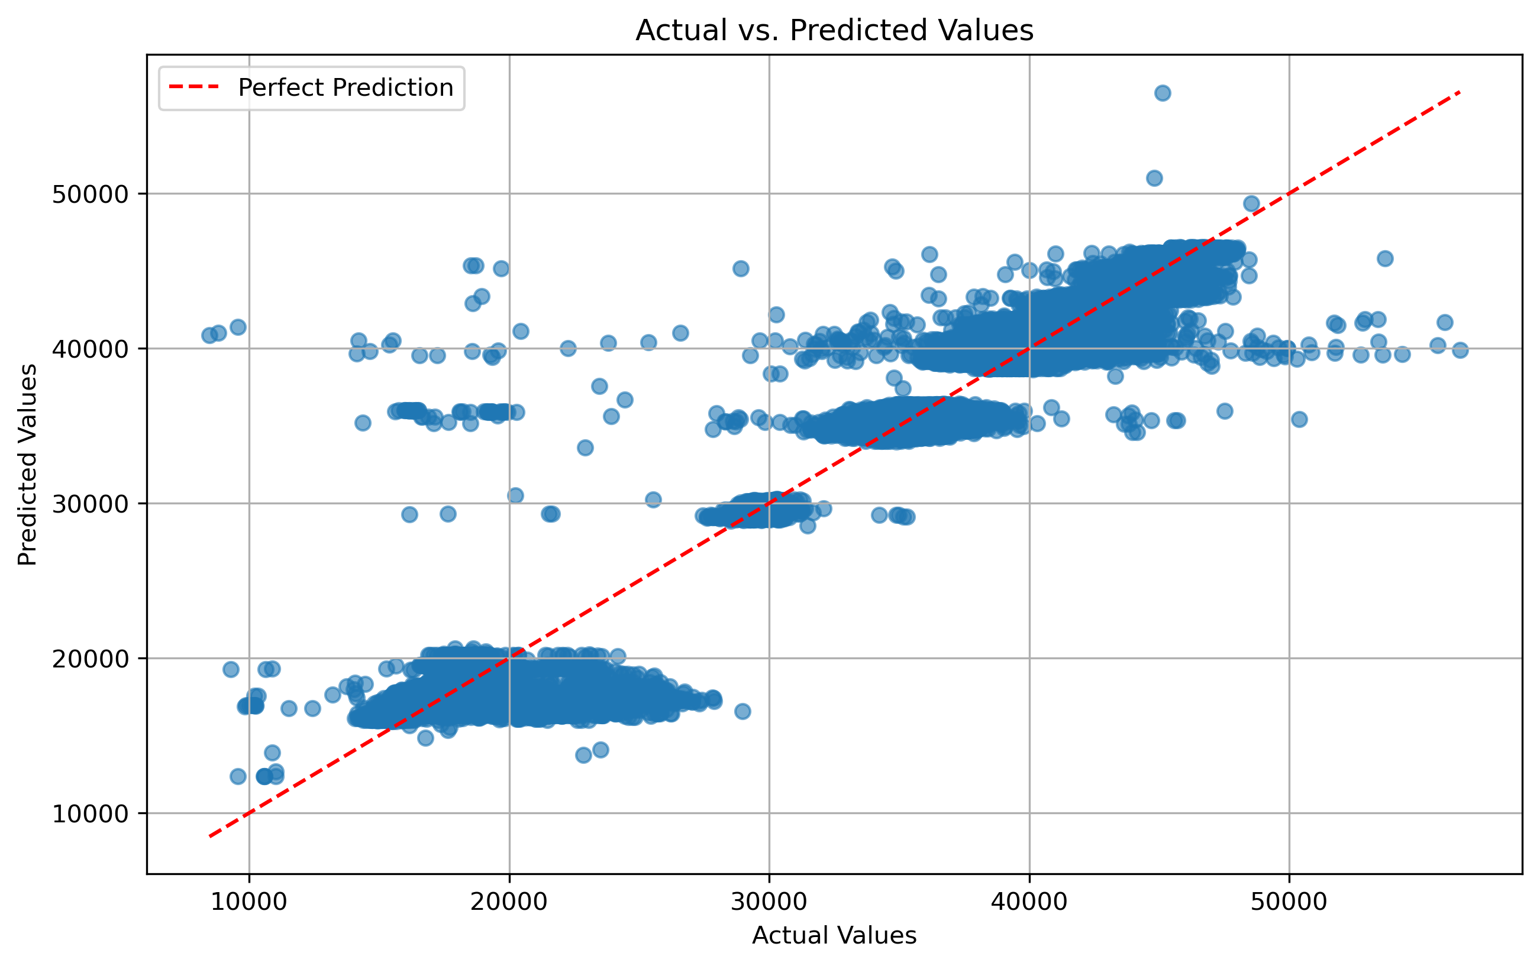
(Graph: Test actual vs. predicted scatter, R² ~0.98: very tight cluster around diagonal.)
  - The largest errors were on the order of 3–4 ksi at most, typically on very high-stress cases – still within acceptable bounds. There were no systemic biases (no alloy where model consistently under/overshot – points for each alloy align well).
Result: The model can accurately predict the expected flow stress for new plates, given their alloy and dimensions, with only minor uncertainty. This satisfies the need for precision in planning typical operations.

MODEL PERFORMANCE – WORST-CASE SCENARIO
- 99th Percentile Model: The LightGBM quantile model provides a conservative prediction. On the test set, ~98% of actual flow stress values fell below the model’s prediction. In other words, it tends to overestimate slightly, such that only ~2% of cases exceed the prediction (and by small margins).
- Safety Margin: The median over-prediction by this model is about 3.8 ksi (MAE). For example, if the true required stress is 40 ksi, the model might predict ~44 ksi. This built-in padding is deliberate.
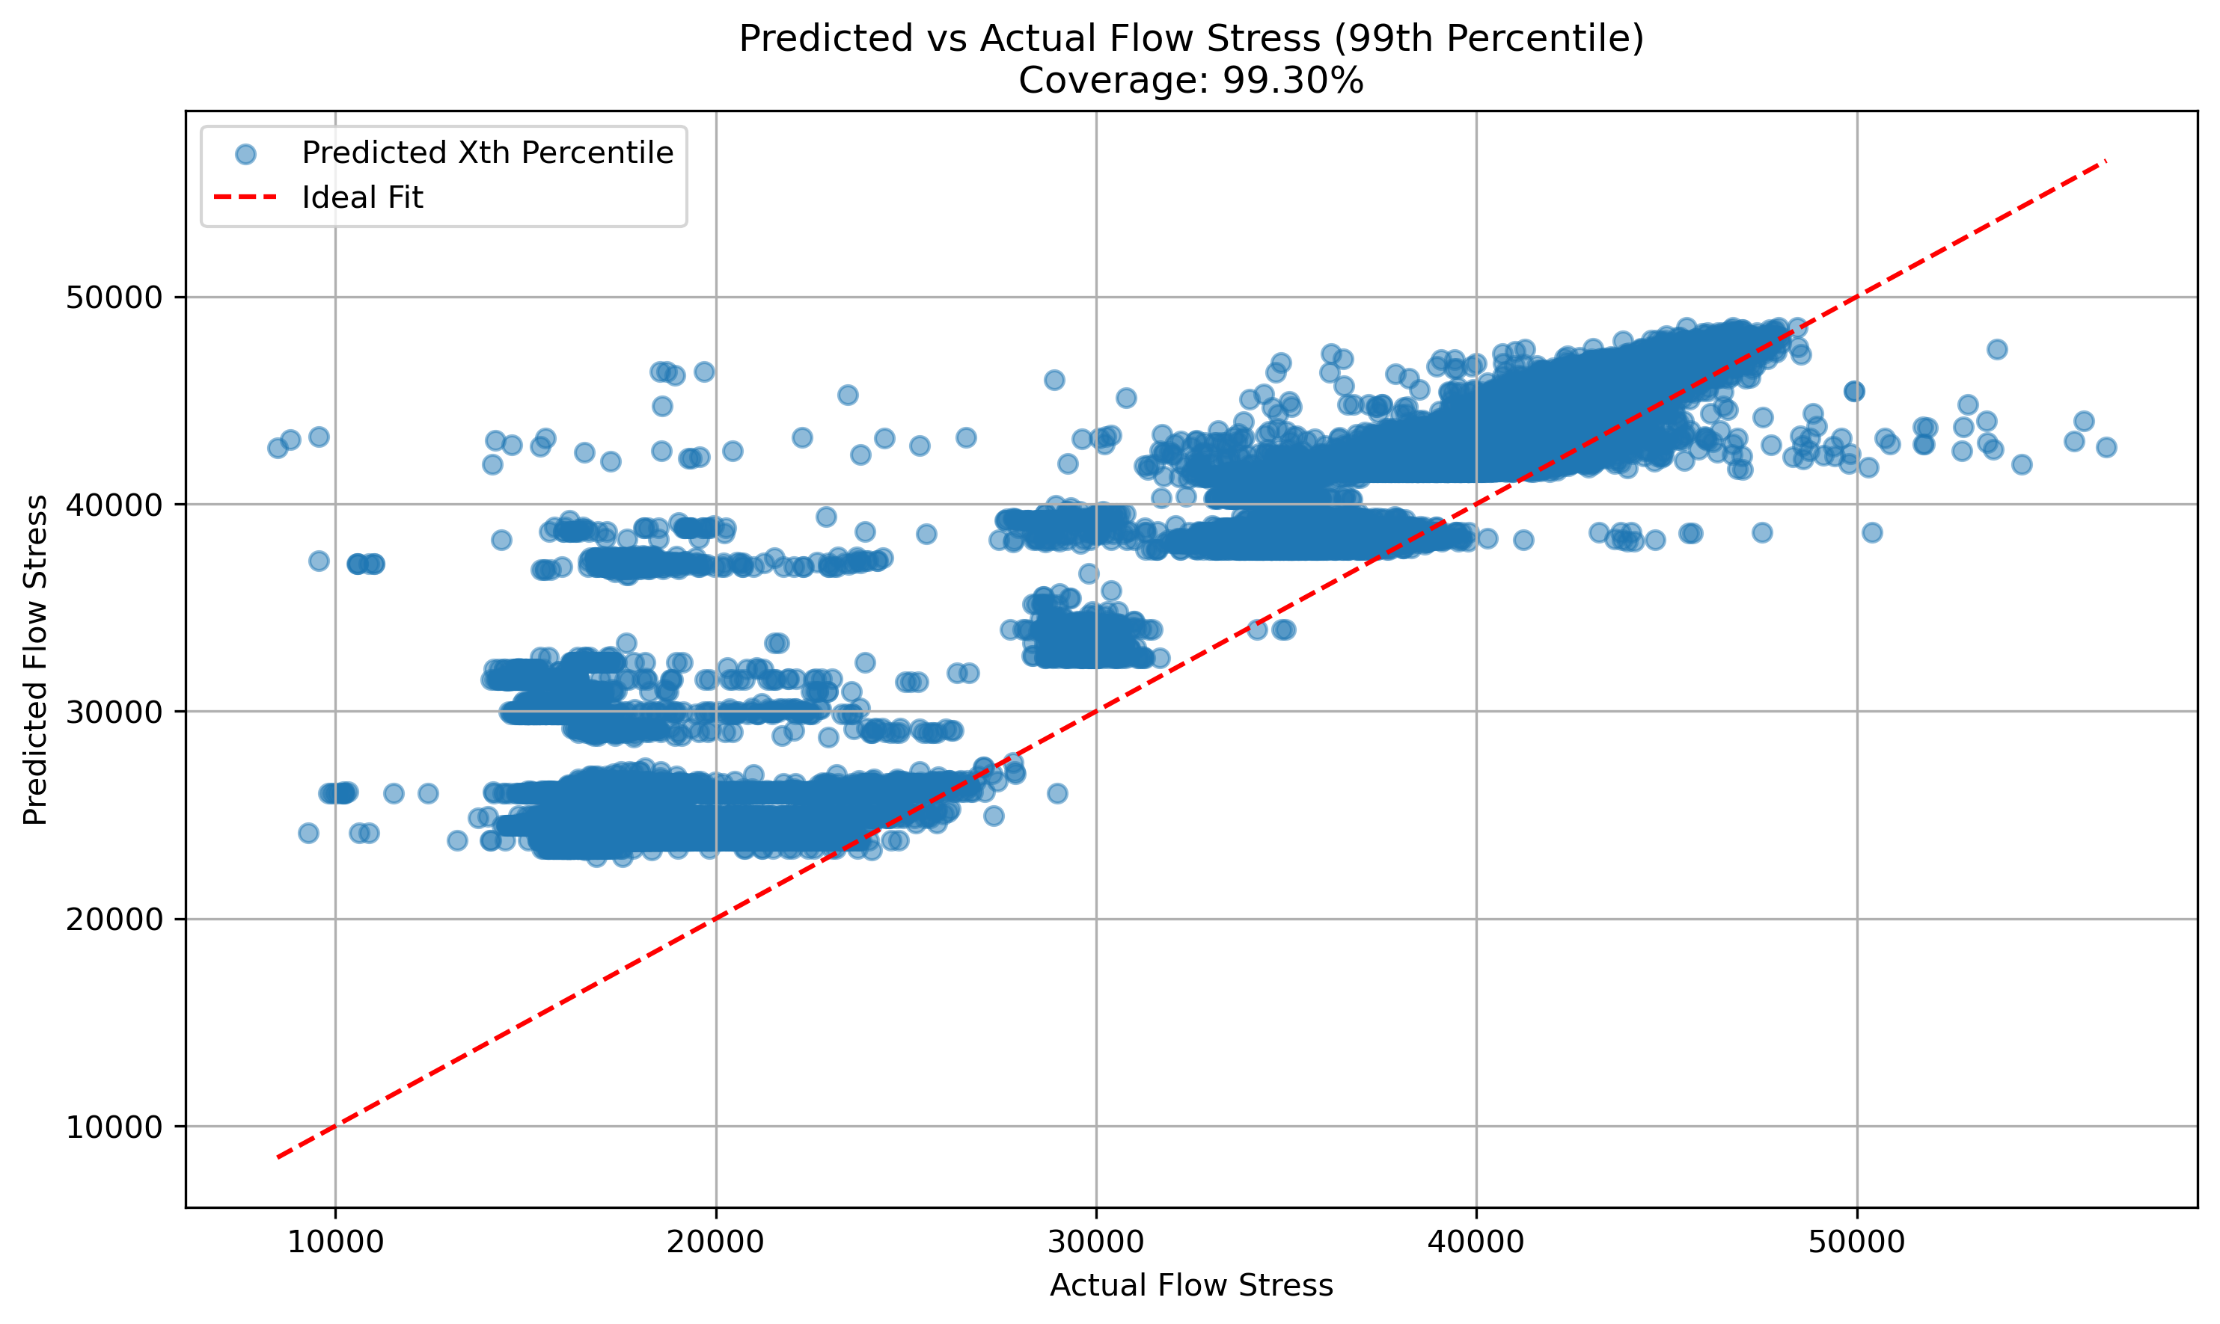
- Verification Plot: Actual vs. Predicted (99% Model) – nearly all actual data points lie below the model’s diagonal line of equality. The few points above the line are within ~1 ksi.
(Graph: Scatter where model’s predictions form an envelope above the actual points).

- Interpretation: This model ensures we almost never under-predict the required force. If it says 50 ksi, we can be ~99% sure the real need will be ≤50 ksi. This addresses the critical safety requirement: no unexpected overloads.
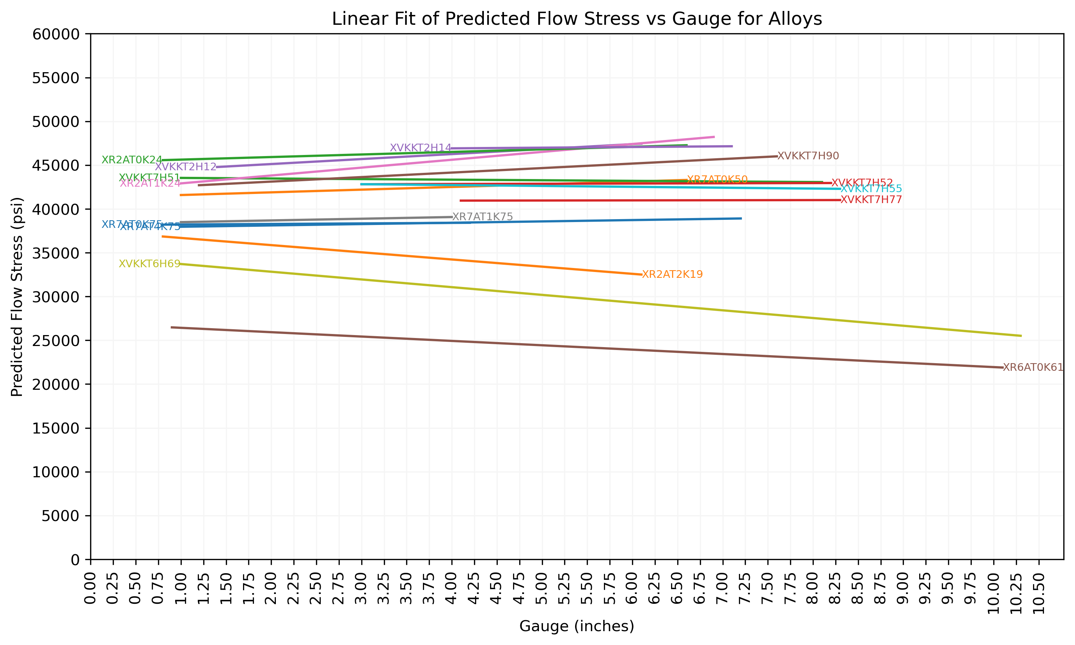
- The trade-off is modest overestimation. But since slightly overestimating force has far less consequence than underestimating (machine capacity can handle a bit less strain easily), this is a favorable balance.
- Integration: In practice, the 99% prediction at each gauge size for each alloy will be used to allow confident and safe decision-making.
(Graph: Scatter where model’s predictions form an envelope above the actual points for a single alloy across the distribution of the gauge).

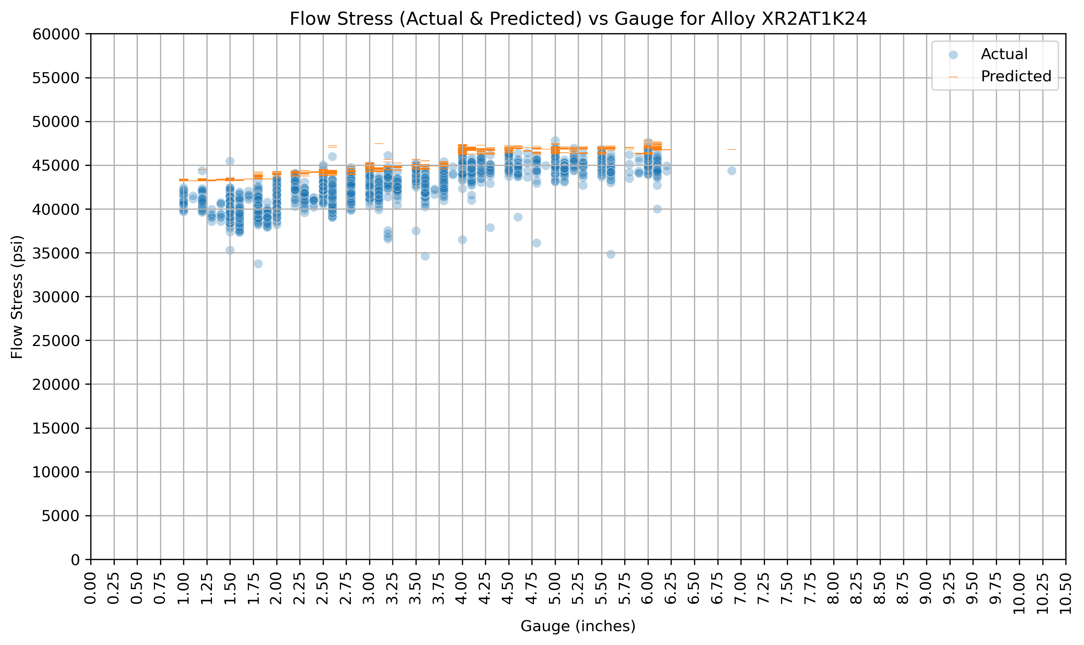
RECOMMENDATIONS FOR ALUMATECH
Using the developed models, AlumaTech should:
- New Product Feasibility Checks: Before attempting any new alloy/geometry, input its specs to the model. If the predicted worst-case flow stress is near machine limits, reconsider the design or prepare an upgrade.
- Optimized Scheduling & Maintenance: Incorporate predicted forces into production planning. Schedule plates with very high predicted stress at appropriate times and alert maintenance for those runs. This proactive approach will reduce equipment strain and downtime.
- Process & Quality Control: Use the model’s expected stress as a benchmark during operations. If actual stretch force deviates significantly from prediction, investigate (it may flag material spec issues or equipment calibration drift). Over time, this will tighten quality consistency – each plate gets stretched with the right force, improving uniformity.
FURTHER RESEARCH & NEXT STEPS
- Per-Alloy Fine-Tuning: Consider training specialized sub-models or adding interaction terms for each alloy group. The global model works well, but minor accuracy gains might be achieved by allowing, say, a slightly different thickness effect curve per alloy.
- Continuous Learning: Set up a pipeline to retrain the model periodically (e.g., yearly) with new stretch data. If AlumaTech introduces new alloys or processes, updating the model will keep predictions reliable. Monitor model vs. actual performance; if accuracy drifts, refresh with latest data.
- Deployment: Integrate the model into user-friendly software for engineers and planners (e.g., a web app or an Excel plugin). This will ensure it's consistently used in workflow. Also, maintain a Model Metrics document – which we have prepared – summarizing model assumptions, features, and performance. This transparency will help stakeholders trust and understand the predictions.
- Next Project Phase: Work on implementing these predictions as part of a digital twin of the stretching process. Combining this data-driven model with physics-based simulations could further enhance predictive power and provide insight into why certain outliers occur (bridging data science with engineering physics).

CONCLUSION
- Accuracy Achieved: The model meets the success criteria – it predicts flow stress within ~3% on average and provides <1-2% risk of underestimation. This gives AlumaTech confidence in using it for decision-making.
- Ready for Use: AlumaTech can now predict stretching forces before production, enabling informed decisions that improve safety, efficiency, and product quality. By implementing the above recommendations, the company will leverage this project into tangible operational benefits – reducing unexpected equipment stress, planning maintenance smarter, and accelerating the development of new plate products with data-driven assurance.

